Norfolk County Council (Barton Bendish)
Emergency Notice

Temporary Traffic Regulation Order 2025
Section 14(2) of the Road Traffic Regulation Act 1984

Barton Bendish (WTRO6081) Notice

In accordance with the provisions of Section 14(2) of the Road Traffic Regulation Act 1984, the Norfolk County Council HEREBY GIVE NOTICE that owing to emergency sewer repairs the use by vehicles (of any class) of the U21246 Buttlands Lane from 50m south of its junction with U21247 Church Road for 40m southwards (the “Road”) in the Parish of Barton Bendish will be temporarily prohibited.

Alternative route is via: Buttlands Lane, Beechamwell Road, Fincham Road, Church Road.

The works promoter for this restriction/closure is: Anglian Water.

The closure/restriction is necessary because of the likelihood of danger to the public or serious damage to the road or both.

The closure/restriction is anticipated to take place from 29th August to 5th September 2025 but the Road may continue to be closed/restricted until the 18th September 2025 where the closure/restriction is still required beyond the anticipated dates.

This Notice shall automatically revoke on the completion of the works / when the closure/restriction is no longer necessary or otherwise on the 18th September 2025 without further notice.

If necessary, this Notice may be extended for an additional 21 days by further Notice and/or for a maximum of 18 months from the date this Notice is effective by further Order.

A person who contravenes, or who uses or permits the use of a vehicle in contravention of the restriction/ closure imposed by the Order shall be guilty of an offence.

Penalty: £1000 maximum fine on conviction and/or endorsement for contravention.

Full details on the closure are available at https://one.network. Any enquiries that cannot be answered on the one.network website should be directed to the West Area Streetworks (Community and Environmental Services Department) contactable by telephone at 0344 800 8020 or email at streetworks@norfolk.gov.uk

Dated this 29th day of August 2025.

Katrina Hulatt
Director of Legal Services (nplaw)
County Hall
Martineau Lane
Norwich
NR1 2DH

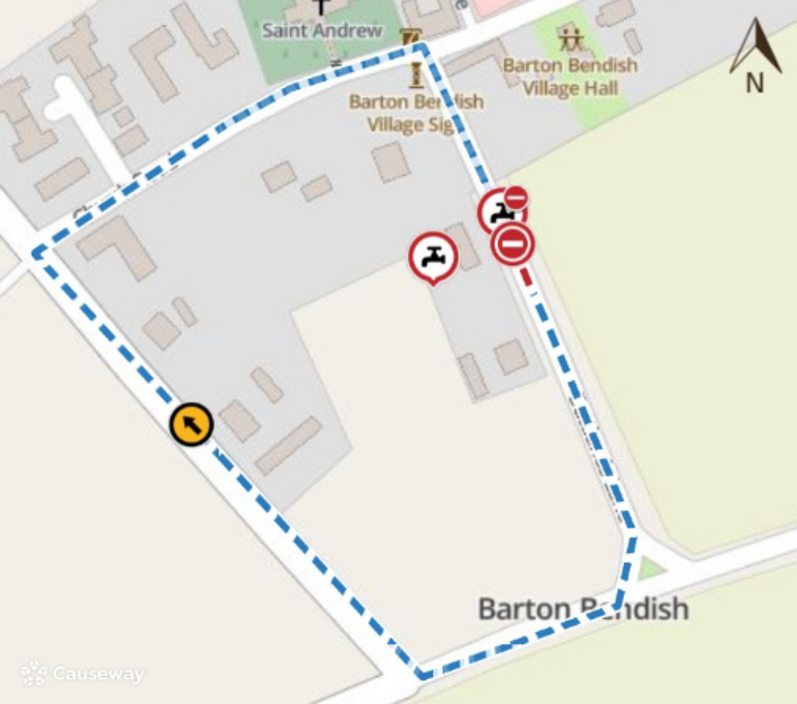

Map data © MapTiler © OpenStreetMap contributors

