Norfolk County Council proposes to make a Temporary Traffic Regulation Order (the “Order”) (WTRO5791) affecting the Eastmoor Road from 180m north of its junction with Oxborough Road for 575m northwards (the “Road”) in the Parish of Barton Bendish to facilitate main laying works, the Road will be temporarily subject to a 30mph speed restriction for the duration of the works/period the restriction is necessary which is anticipated to be from 4th August to 4th November 2025, but may continue to be restricted until the 3rd February 2027 where the closure/restriction is still required beyond the anticipated dates.

Alternative route is via: N/A.

The works promoter for this restriction/closure is: Anglian Water.

Vehicular access will be permitted to a final destination in the Road where signs indicating such access is possible and permitted are in place.

The Order shall automatically revoke on the completion of the works/when the restriction is no longer necessary or otherwise on the 3rd February 2027 without further notice.

If necessary, the restriction could run for a maximum period of 18 months from the date the Order is effective.

A person who contravenes, or who uses or permits the use of a vehicle in contravention of the restriction imposed by the Order shall be guilty of an offence.

Penalty: £1000 maximum fine on conviction and/or endorsement for contravention.

In the event of the start date being delayed the new start date will be displayed on site in advance.

Full details on the closure are available at https://one.network. Any enquiries that cannot be answered on the one.network website should be directed to the West Area Streetworks (Community and Environmental Services Department) contactable by telephone at 0344 800 8020 or email at streetworks@norfolk.gov.uk

Dated this 25th day of July 2025.

Katrina Hulatt
Director of Legal Services (nplaw)
County Hall
Martineau Lane
Norwich
NR1 2DH

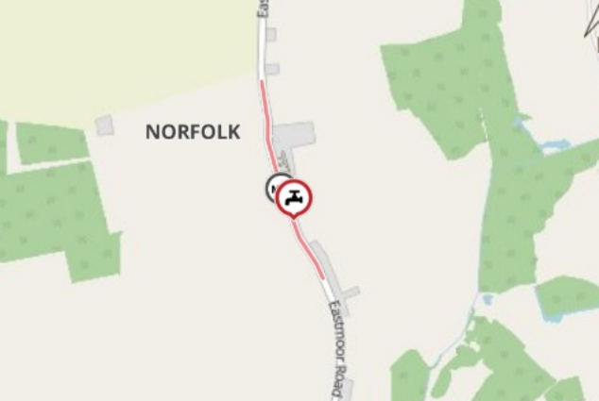
Imagery © 2025 MapTiler | Imagery © 2025 Hexagon | © MapTiler © OpenStreetMap contributors

