Norfolk County Council (Fincham)
Emergency Notice

Temporary Traffic Regulation Order 2024
Section 14(2) of the Road Traffic Regulation Act 1984

Fincham (WTRO5008) Notice

In accordance with the provisions of Section 14(2) of the Road Traffic Regulation Act 1984, the Norfolk County Council HEREBY GIVE NOTICE that owing to burst water main the use by vehicles (of any class/specific class) of the Boughton Long Road from 680m south of its junction with Fincham Road for 50m southwards (the “Road”) in the Parish of Fincham will be temporarily prohibited/restricted.

Alternative route is via: Boughton Long Road, Mill Hill Road, The Green, Chapel Road, Oxborough Road, Stoke Ferry Road, Eastmoor Road, Beechamwell Road (Barton Bendish, Boughton, Fincham).

The closure/restriction is necessary because of the likelihood or danger to the public or serious damage to the road or both.

The closure/restriction is anticipated to take place from 21st to 28th May 2024 but the Road may continue to be closed/restricted until the 10th June 2024 where the closure/restriction is still required beyond the anticipated dates.

This Notice shall be in effect from 21st May 2024 to 10th June 2024 or until the closure/restriction is/are no longer necessary, whichever is the earliest.

This Notice shall automatically revoke on the completion of the works / when the closure/restriction is no longer necessary or otherwise on the 10th June 2024 without further notice.

If necessary, this Notice may be extended for an additional 21 days by further Notice and/or for a maximum of 18 months from the date this Notice is effective by further Order.

A person who contravenes, or who uses or permits the use of a vehicle in contravention of the restriction/ closure imposed by the Order shall be guilty of an offence.

Penalty: £1000 maximum fine on conviction and/or endorsement for contravention.

Full details on the closure are available at https://one.network. Any enquiries that cannot be answered on the one.network website should be directed to the West Area Streetworks (Community and Environmental Services Department) contactable by telephone at 0344 800 8020 or email at streetworks@norfolk.gov.uk

Dated this 21st day of May 2024.

Katrina Hulatt
Director of Legal Services (nplaw)
County Hall
Martineau Lane
Norwich
NR1 2DH
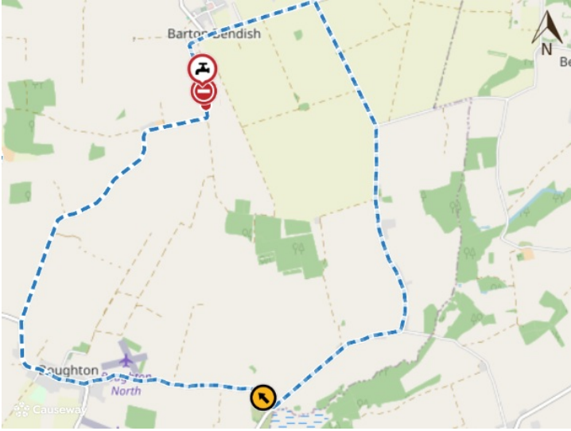
Imagery © 2024 MapTiler | Imagery © 2024 Hexagon | © MapTiler © OpenStreetMap contributors

