NORFOLK COUNTY COUNCIL proposes to make a Temporary Traffic Regulation Order (WTRO4940) affecting the A1122 from its junction with A134 Lynn Road to its junction with Fincham Road in the PARISH OF FINCHAM to facilitate surfacing and stud replacement works.

The road will be temporarily closed (except for access) from 21st May to 15th June 2024 only whilst signs indicating closures are in place.

Alternative route is via: Downham Road, High Street, Main Road, Swaffham Road, Lynn Road, A47, Whitsands Road, Cley Road, Theatre Street, Globe Hill, London Street, Watton Road, Brandon Road, Redland Road, South Pickenham Road, Crown Road, Swaffham Road Roundabout, Cranwich Road, Thetford Road, Whittington Hill, Stoke Ferry Bypass A134, Stoke Road (Hilborough , Ickburgh , Barton Bendish , Stoke Ferry, Swaffham, Beachamwell Stradsett , Fincham Great Cressingham , Northwold , Mundford, West Dereham, Cranwich, Cockley Cley, Wereham).

If necessary, the restriction could run for a maximum period of 18 months from the date of the Order.

Penalty: £1000 maximum fine on conviction and/or endorsement for contravention.

In the event of the start date being delayed the new start date will be displayed on site in advance.

The team dealing with enquiries at Norfolk County Council is West Area Streetworks (Community and Environmental Services Department) contactable by telephone at 0344 800 8020 or email at streetworks@norfolk.gov.uk. Details are also available at https://one.network.

Dated this 10th day of May 2024.

Katrina Hulatt
Director of Legal Services (nplaw)
County Hall
Martineau Lane
Norwich
NR1 2DH

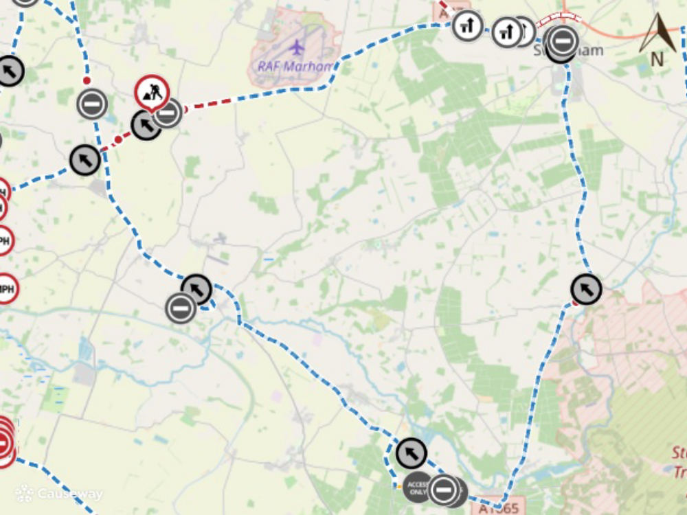
Imagery © 2023 MapTiler | Imagery © 2023 Hexagon | © MapTiler © OpenStreetMap contributors

